**Lab Assignment 11**

**Student Name: Navneet P**

**Student ID: AF0416803**

**Topic: Exception Handling**

**Q1. Write a Python program that prompts the user to input an integer and raises a ValueError exception if the input is not a valid integer.**

**Solution:**

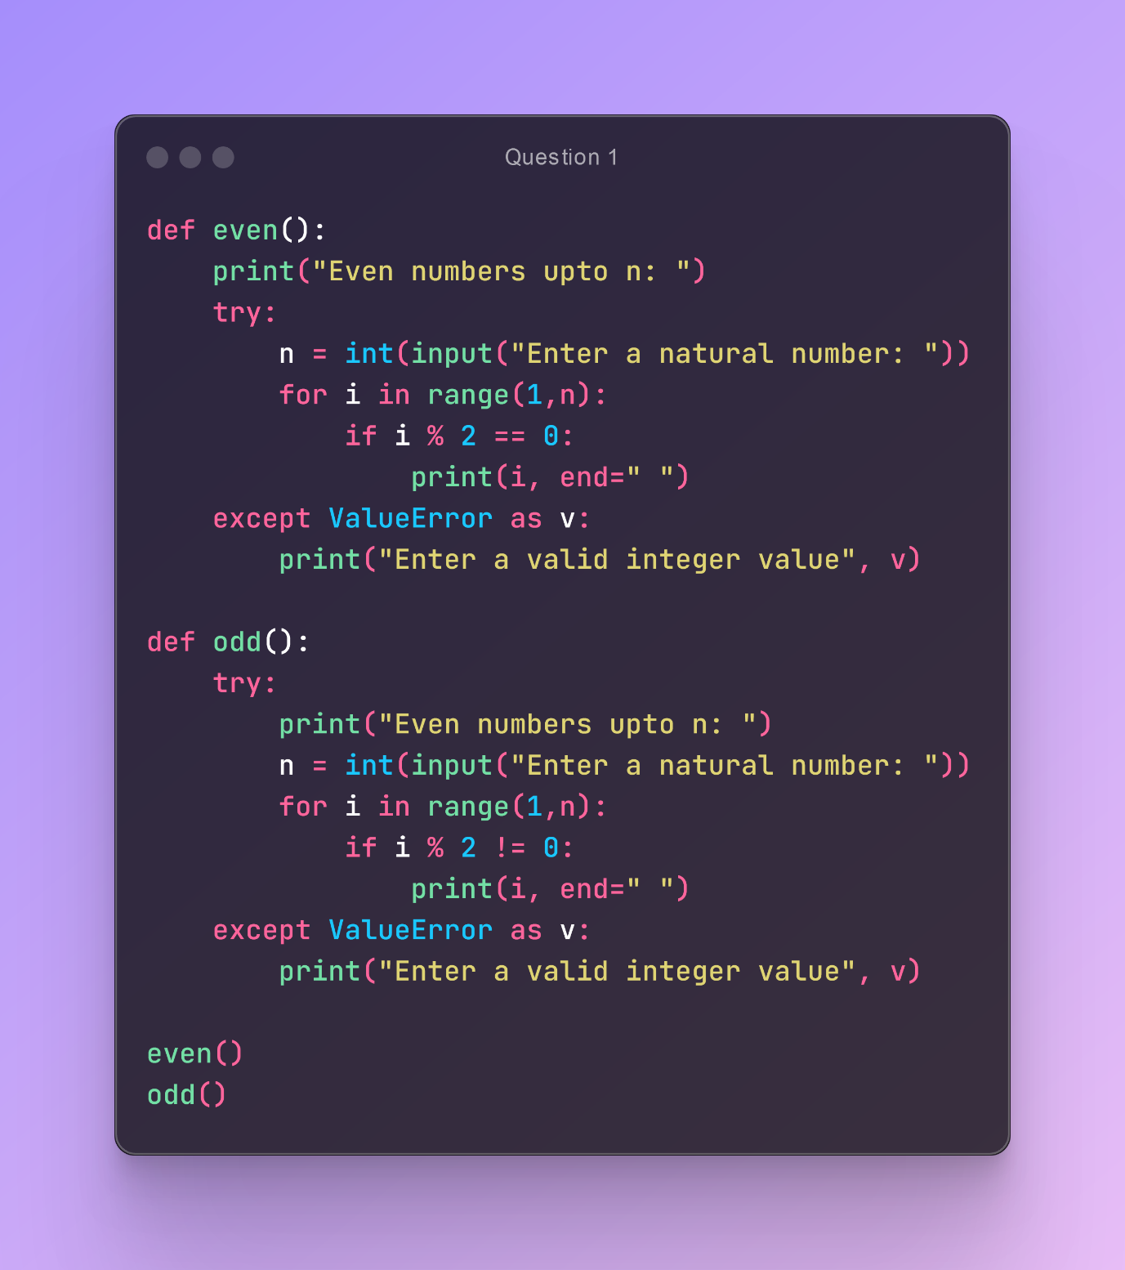

**Output:**

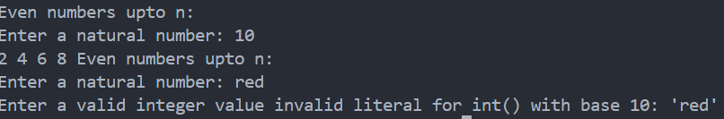

**Q2. Write a Python program to handle a ZeroDivisionError exception when dividing a number by zero.**

**Solution:**

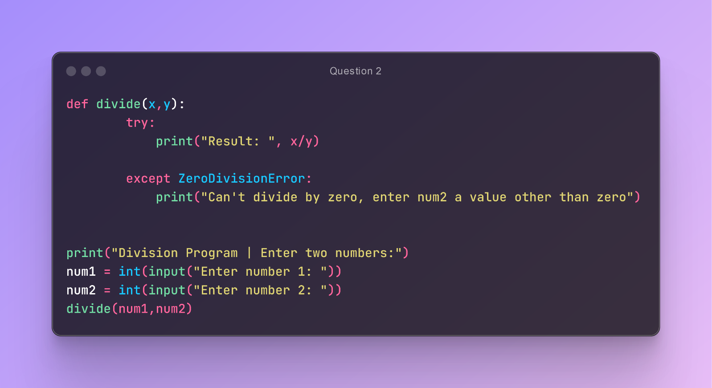

**Output:**

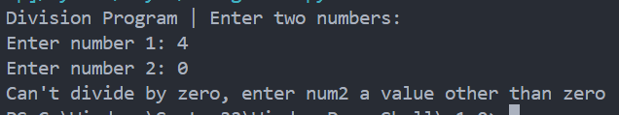

**Q3. Write a Python program that opens a file and handles a FileNotFoundError exception if the file does not exist.**

**Solution:**

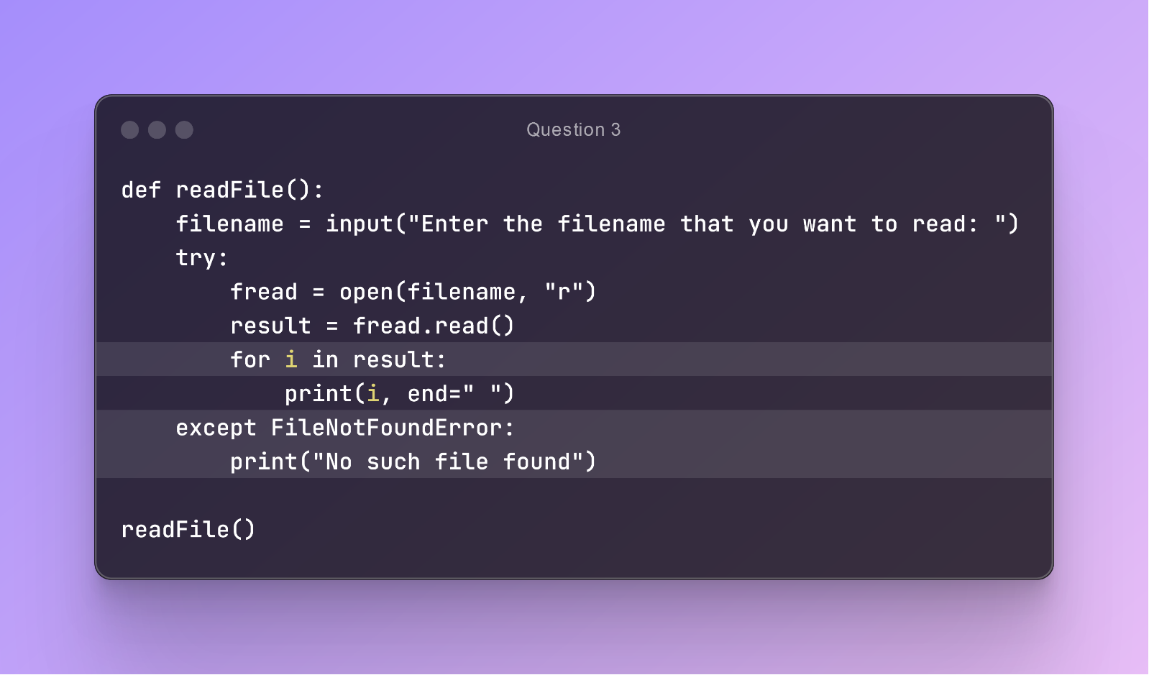

**Output: When file is available**

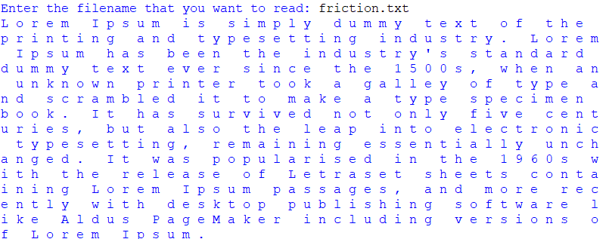

**When file is not available**



**Q4.  Write a Python program that prompts the user to input two numbers and raises a TypeError exception if the inputs are not numerical.**

**Solution:**

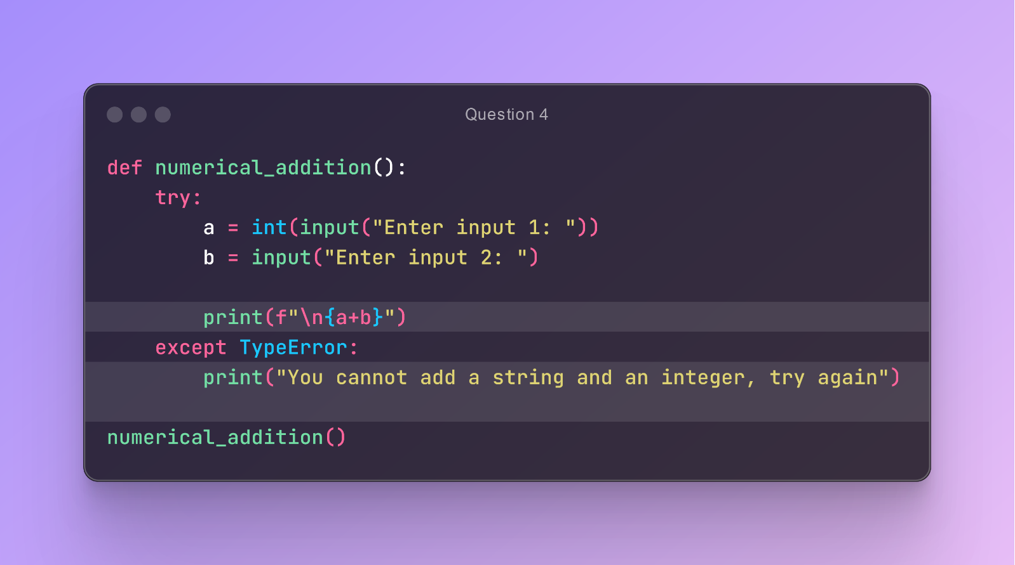

**Output:**

